

Mohammad Ali Jinnah University

Chartered by Government of Sindh - Recognized by HEC

**Lab Task 3**

**Name:** Muhamad Fahad

**Id:** FA19-BSSE-0014

**Subject:** Data Structures and Algorithms Lab (CS 2511)

**Lab Title:** Bubble Sorting

**Section:** AM

**Teacher:** MUHAMMAD MUBASHIR KHAN

**Date:** Thursday, October 29, 2020

**1) Implement Bubble Sort.**

**Code:**

import java.util.Arrays;  
import java.util.Scanner;  
  
public class BubbleSorting1 {  
 public static void main(String[] args) {  
 System.*out*.println("1) Implement Bubble Sort.\n");  
  
 int length;  
 Scanner scan = new Scanner(System.*in*);  
  
 System.*out*.print("Enter the Length of the array: ");  
 length = scan.nextInt();  
 int arr[] = new int[length];  
  
 for (int i = 0; i < length; i++) {  
 System.*out*.print("Enter the Value of index: "+i+" : ");  
 arr[i] = scan.nextInt();  
 }  
  
 System.*out*.println("\nArray before bubble sorting: "+ Arrays.*toString*(arr));  
  
 int swap;  
 for (int i = 0; i < length-1; i++) {  
 for (int j = 0; j < (length-i)-1; j++) {  
 if (arr[j] > arr[j+1]) {  
 swap = arr[j];  
 arr[j] = arr[j+1];  
 arr[j+1] = swap;  
 }  
 }  
 }  
  
 System.*out*.println("\nArray After bubble sorting: "+ Arrays.*toString*(arr));  
  
 }  
}

**Output:**

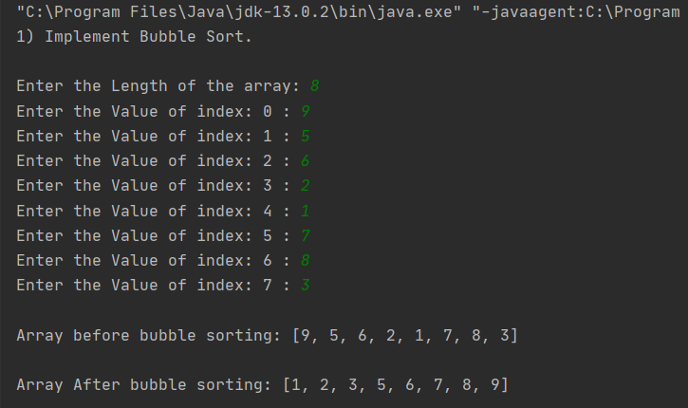

**2) Implement Bubble Sort for descending order.**

package com.company;  
  
import java.util.Arrays;  
import java.util.Scanner;  
  
public class BubbleSorting2 {  
 public static void main(String[] args) {  
 System.*out*.println("2) Implement Bubble Sort for descending order.\n");  
  
 int length;  
 Scanner scan = new Scanner(System.*in*);  
  
 System.*out*.print("Enter the Length of the array: ");  
 length = scan.nextInt();  
 int arr[] = new int[length];  
  
 for (int i = 0; i < length; i++) {  
 System.*out*.print("Enter the Value of index: "+i+" : ");  
 arr[i] = scan.nextInt();  
 }  
  
 System.*out*.println("\nArray before descending order bubble sorting: "+ Arrays.*toString*(arr));  
  
 int swap;  
 for (int i = 0; i < length-1; i++) {  
 for (int j = 0; j < (length-i)-1; j++) {  
 if (arr[j] < arr[j+1]) {  
 swap = arr[j];  
 arr[j] = arr[j+1];  
 arr[j+1] = swap;  
 }  
 }  
 }  
  
 System.*out*.println("\nArray After descending order bubble sorting: "+ Arrays.*toString*(arr));  
  
 }  
}

**Output:**

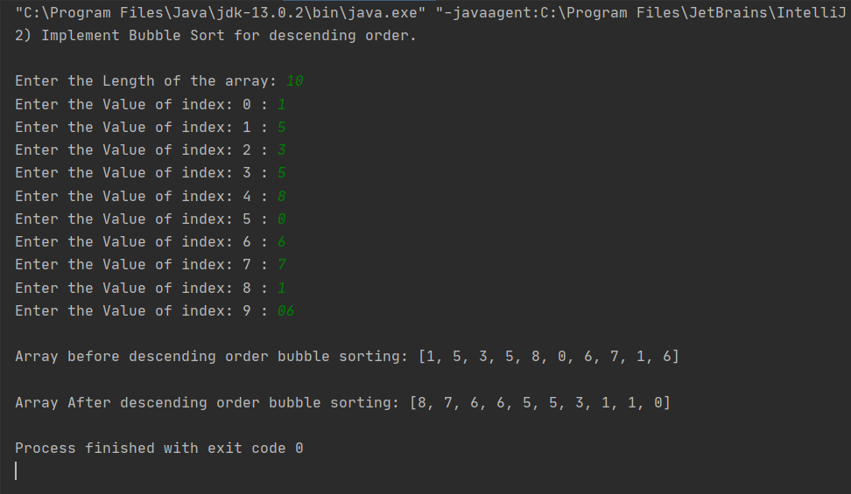

**3) In Word Document**

import java.io.BufferedReader;  
import java.io.IOException;  
import java.io.InputStreamReader;  
import java.util.*;  
  
  
public class BubbleSorting3 {  
 public static void main(String[] args) throws IOException {  
 int length,size,i,j;  
 String temp[];  
  
 BufferedReader scan = new BufferedReader(new InputStreamReader(System.*in*));  
 temp = scan.readLine().split(" ");  
  
 length = Integer.*parseInt*(temp[0]);  
 size = Integer.*parseInt*(temp[1]);  
  
 String UserInput[][] = new String[length][size];  
  
 for (i = 0; i < length; i++) {  
 temp = scan.readLine().split(" ");  
 for (j = 0; j < size; j++) {  
 UserInput[i][j] = temp [j];  
 }  
 }  
  
  
 for (i = 0; i < length-1; i++) {  
 for (j = 0; j < (length-i)-1; j++) {  
  
 boolean match = (Integer.*parseInt*(UserInput[j][size-1])) < (Integer.*parseInt*(UserInput[j+1][size-1]));  
 boolean match2 = ((Integer.*parseInt*(UserInput[j][size-1])) == (Integer.*parseInt*(UserInput[j+1][size-1]))) && (UserInput[j][0].charAt(0) > UserInput[j+1][0].charAt(0));  
  
 if (match || match2) {  
 temp = UserInput[j];  
 UserInput[j] = UserInput[j+1];  
 UserInput[j+1] = temp;  
 }  
   
  
 }  
 }  
  
 for (i = 0; i < 2; i++) {  
 System.*out*.println(UserInput[i][0]);  
 }  
 }  
}

**Output:**

